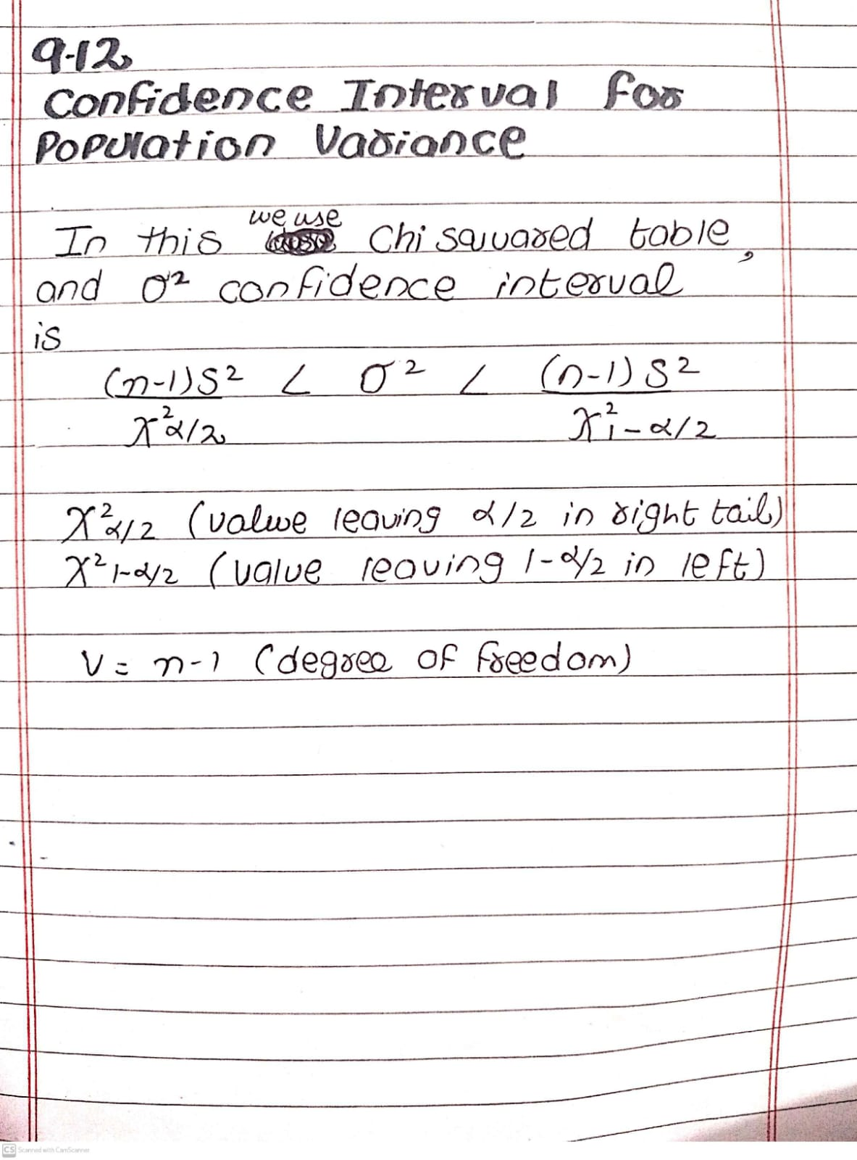
Practice Question:
The Following are the weights,in decagrams,of10 packages of grass seed distributed by a certain company: 46.4,46.1,45.8,47.0,46.1,45.9,45.8,46.9,45.2,and 46.0. Find a 95% confidence interval for the variance of the weights of all such packages of grass seed distributed by this company,assuming a normal population.
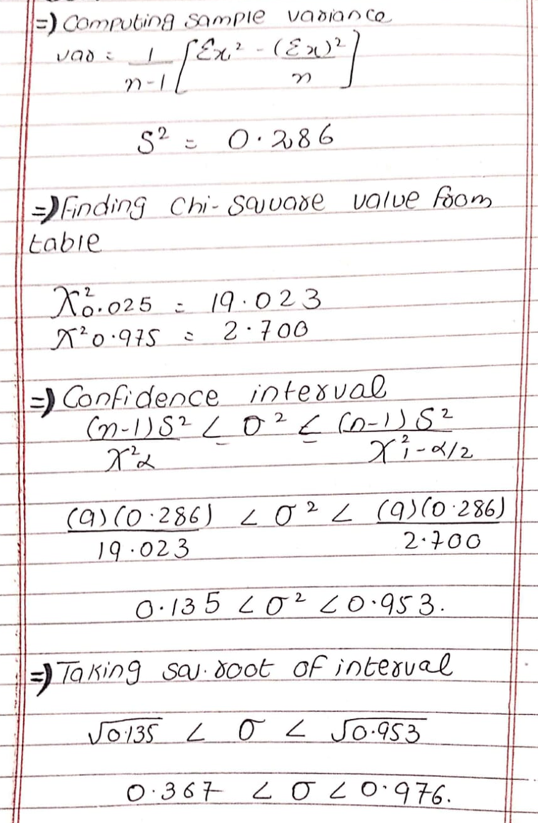

Practice question:
A factory produces metal rods, and a random sample of 20 rods is selected to measure their diameters (in millimeters):
5.02, 5.03, 5.01, 5.04, 5.00, 5.02, 5.05, 5.01, 5.03, 5.00, 5.02, 5.04, 5.00, 5.03, 5.01, 5.02, 5.00, 5.04, 5.03, 5.01
(a) Compute the sample variance (S²).
(b) Find a 99% confidence interval for the population variance (σ²).
(c) Find a 99% confidence interval for the population standard deviation (σ).
